TECHNICAL PROJECT REPORT

# Title of Invention / Project:

**Cricket game with LED, Arduino**

# Team Members / Inventors:

|  |  |  |  |  |  |
| --- | --- | --- | --- | --- | --- |
| **S. No.** | **Name** | **Department** | **Designation** | **Mobile** | **E-Mail** |
| 1. | Pratyush Srivastava | ECE-2 | Team Member | 6203321490 | pratyush0367@gmail.com |
| 2. | Devendra Singh | ECE-2 | Team Member | 9871196204 | devendrathores@gmail.com |
| 3. | Ashutosh | ECE-2 | Team Member | 8006029400 | kashyapshanu666@gmail.com |
| 4. | Minhaj | ECE-2 | Team Member | 7901912121 | minhajulislam77795@gmail.com |
| 5. | Khushal Thakur | ECE | Mentor | 9646030764 | khushal.thakur@cumail.in |
| 6. | Anshul Sharma | ECE | Mentor | 9478697475 | anshulsharma.ece@cumail.in |
| 7. | Kiran Jot Singh | ECE | Mentor | 9463909689 | kiranjotsingh.ece@cumal.in |
| 8. | Divneet Singh Kapoor | ECE | Mentor | 9878422653 | divneet.ece@cumail.in |

Section – 1 (IPR Related)

* **Problem your project is solving**

This project is not about any problem solving this project is only based on a type of entertainment. This project is only for the entertainment.

* **How are you solving that (solution)?**

This project is made with the help of led bulbs and Arduino UNO

* **Additional modifications that can cater to improved solution**

By adding an LCD display screen to show the total score can make it more attractive.

# **Existing state-of-the-art and Drawbacks in existing state-of-the-art**

|  |  |  |
| --- | --- | --- |
| **S. No.** | **Existing state of art** | **Drawbacks in existing state of art** |
| 1 | LED Cricket game with the help of Arduino UNO. | Not able to display the scores in the LCD, Calculation of the score is in manual form. |
| 2 | In this game there are 7 LED in which led will show the value of runs (1,2,4,6), out and lbw. When we switch on the game all the led will start blinking randomly and when the stop button will pressed any one of the 7 led’s will continue to blink and other led’s will be get off for 10 seconds and after 10 seconds all the led will start blinking again. In this the player will be given only 6 trials and if he/she will be get out in between the three trials he/she have to left the game and it will be the turn of the next player. | There are many rules in the cricket game but we can’t implement all those rules in the game due to the shortage of the led’s |

# Novel/Additional modifications that you can propose to improve upon

# **drawbacks**

1. The drawbacks of this project is that we haven’t include the LCD screen to show the score of the game
2. Least no of leds are used

# **Advantages**

If we include both the things then it will make the project more attractive and entertaining.

# Block Diagram

Section – 2 (Real Project)

# Materials Quantity price

|  |  |  |
| --- | --- | --- |
| 1. Adapter | 1pc | Rs.200/- |
| 1. ARDUINO UNO | 1pc. | Rs. 400/- |
| 1. LED | 8pc. | Rs.20/- |
| 1. Switch | 1pc. | Rs.5/- |
| 1. Wires | 5 meters | Rs.35/- |
| 1. Resistance(10K ohm) | 8pc | Rs.15/- |
| 1. Whole Structure |  | Rs.150/- |

# Circuit Diagram

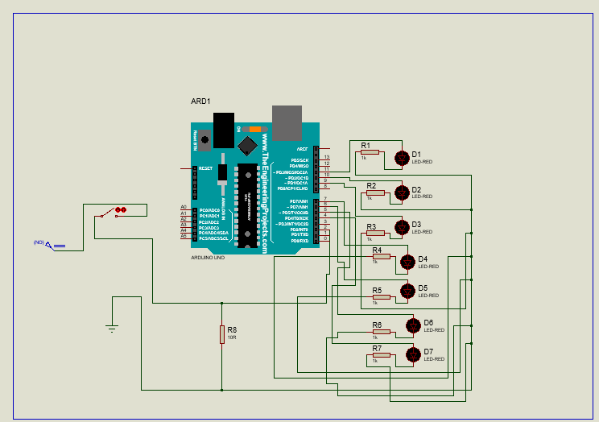

# **Steps of Circuit Completion**

**Step 1- Circuit design Step 2- Circuit Completion**

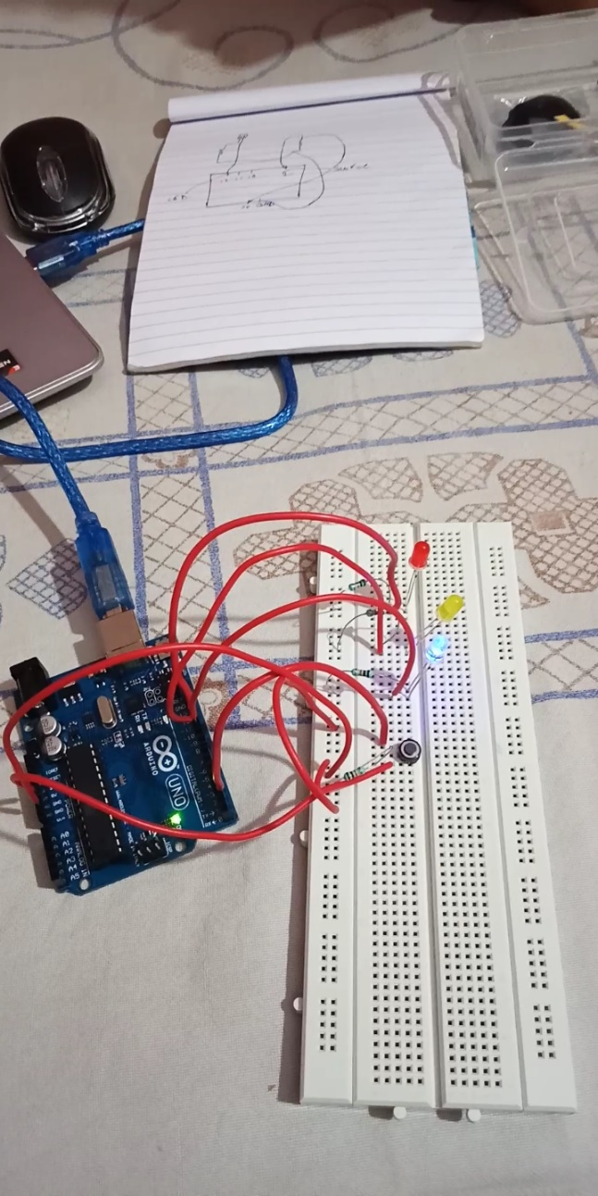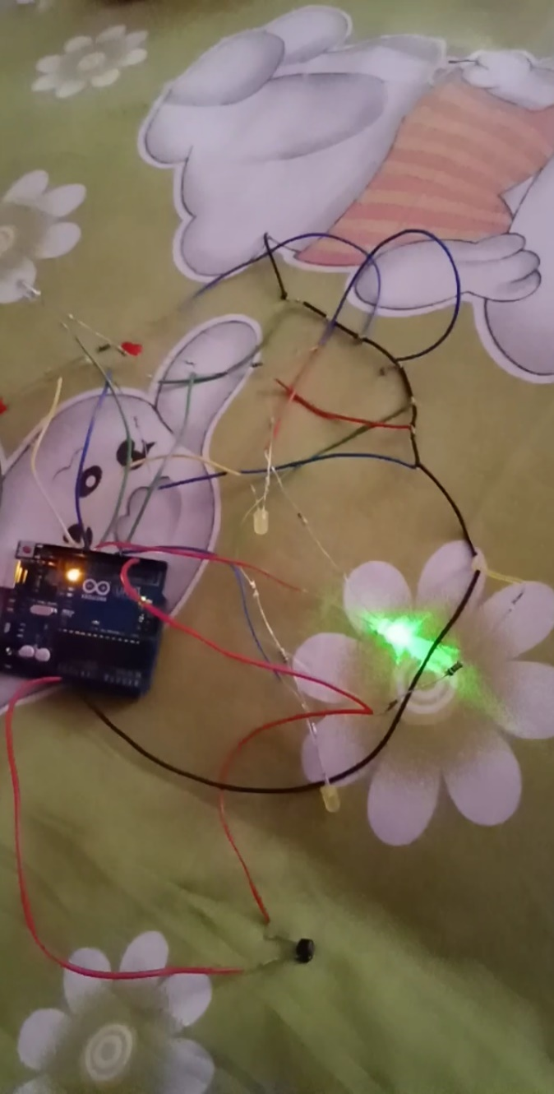

**Step 3- Structure Making Step 4- Structure Completion**

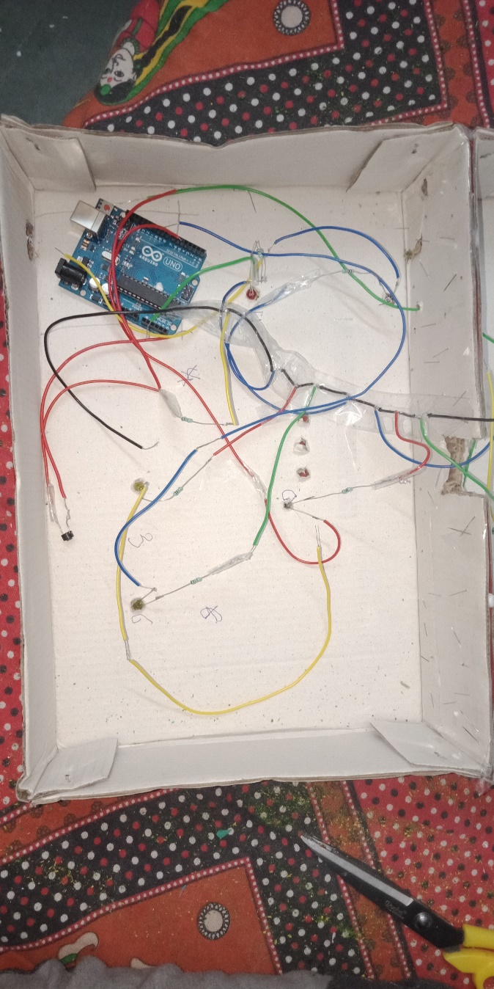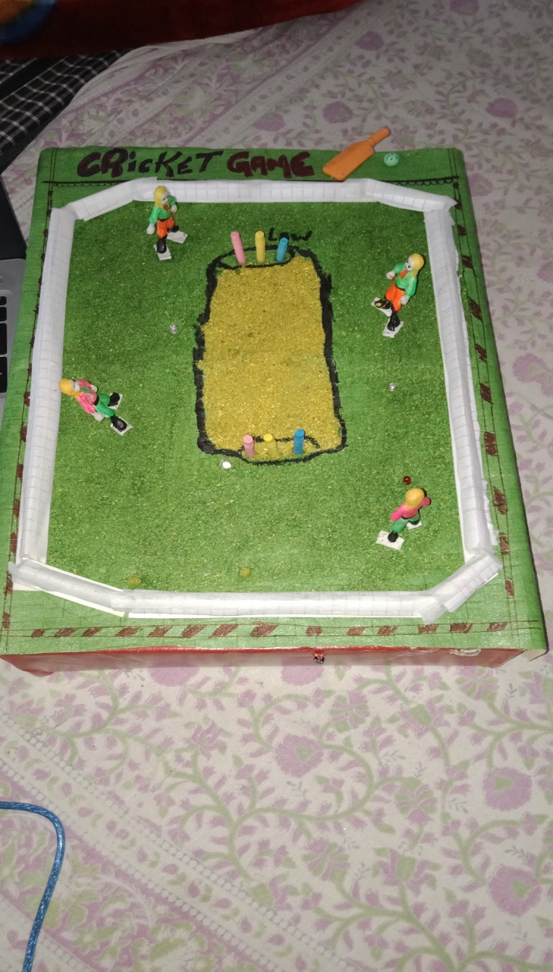

# Program Code

<https://github.com/pratyush0596/lab-course/blob/master/programming1/sketch_oct25b.ino>